**inventory collection app**

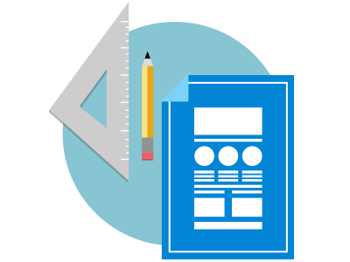

**Project | Web Responsive**

**Wireframe**

